AZA 2016 MID-YEAR MEETING March 19-24, 2016 • Omaha, NE
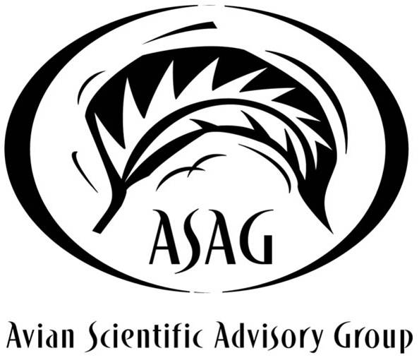
AVIAN SCIENTIFIC ADVISORY GROUP/AVIAN TAG AGENDA
Sunday, March 20-Thursday, March 24

Sunday, March 20
8:00 am – 9:00 am
- Charadriiformes TAG (Room 215)
9:00 am – 10:00 am
- Struthioniformes TAG (Room 214)
- Piciformes TAG (Room 215)
10:00 am – 11:00 am
- PACCT TAG (Room 215)
10:00 am – 12:00 pm
- Penguin TAG – closed 10:00 am – 11:00 am (Room 214)
11:00 am – 12:00 pm
- Coraciiformes TAG (Room 215)
12:00 pm – 1:00 pm
- TAG Mart and Lunch (Grand Ballroom)
1:00 pm – 2:00 pm
- Galliformes TAG (Room 214)
1:00 pm – 2:30 pm
- Raptor TAG (Room 215)
2:00 pm – 3:00 pm
- Gruiformes TAG (Room 214)
2:30 pm – 4:30 pm
- Anseriformes TAG (Room 215)
3:30 pm – 4:30 pm
- Columbiformes TAG (Room 214)
4:00 pm – 5:30 pm
- Whooping Crane SSP (Room 211)

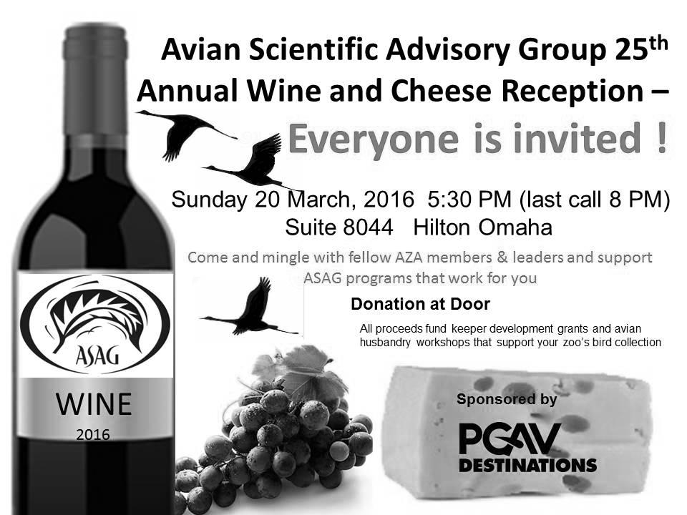

Monday, March 21
Room 215
8:00 am – 5:30 pm
Avian SAG – Parrot TAG Workshop
- Welcome; Opening Remarks
  - Jessica Meehan & Joe Barkowski, AZA Parrot TAG
- AZA Parrot TAG Updates
  - Joe Barkowski, AZA Parrot TAG
- EAZA Parrot TAG Updates
  - Simon Bruslund, EAZA Parrot TAG
- Data for Parrot Reproduction through the Years
  - Joe Barkowski, AZA Parrot TAG
- Mixed Species Options
  - Josh Caraballo, Tampa's Lowry Park Zoo
- Squawk Talk - "What's in a Name?" Nashville Zoo
  - Laura Vague, Nashville Zoo
- What the Flock?? Managing a Pandemonium of Parrots
  - Part 1: Simon Bruslund, EAZA Parrot TAG
  - Part 2: Scott Newland, Sedgwick County Zoo
  - Part 3: Kimberly Klosterman, Cincinnati Zoo
  - Panel Q&A: Jessica Meehan & Joe Barkowski, AZA Parrot TAG
Break/Poster Session
- ABV (20min lecture/10min Q&A)
  - Jennifer D’Agostino, DVM, AZA Parrot TAG
- What Makes a Great Parrot Exhibit? Best Practices in Housing Parrots
  - Scott Newland, Sedgwick County Zoo
  - Joop Kuhn, San Diego Zoo
  - Chad Comer, Blank Park Zoo
  - Panel Q&A: Jessica Meehan & Joe Barkowski, AZA Parrot TAG
Lunch/Poster Session/TAG Mart
- Squawk Talk - Pesquet's Parrot Breeding at St. Augustine Alligator Farm
  - Gen Anderson, St. Augustine Alligator Farm
- General Parrot Health/Testing/Preship
  - Jennifer D’Agostino, DVM, AZA Parrot TAG
- Closed Banding of Parrot Chicks
  - Tom Mortimer, Tulsa Zoo
- Scarlet Macaw Population Recovery in the Maya Biosphere Reserve, Guatemala
  - David Oehler, WCS
- Nestbox Design and Usage
  - Phil Horvey, Sedgwick County Zoo
- Squawk Talk - Education Parrot Presentations at Oregon Zoo
  - Tanya Paul, Oregon Zoo
Break/Poster Session
- Parrot Nutrition
  - Liz Koutsos, Mazuri
- Squawk Talk - Conure Training at North Carolina Zoo
  - Erin Masterson, North Carolina Zoo
- Feather Plucking
  - Joe Barkowski, AZA Parrot TAG
- Parrot-on-a-Stick and Other Parrot Welfare Situations (Ambassador Animals, etc)
  - Moderator-led Audience Discussion, AZA Parrot TAG
- Closing Remarks
  - Jessica Meehan & Joe Barkowski, AZA Parrot TAG

Wednesday March 23
Room 215
10:45 am – 12:00 pm
Ciconifformes TAG
12:00 pm – 1:00 pm
Lunch (Grand Ballroom)
1:00 pm – 5:30 pm
Avian SAG General Session
- Welcome
- ASAG Action Plan
  - Tom Schneider, Curator of Birds, Detroit Zoo
- ASAG Website Updates
  - Kevin Graham, Dallas Zoo
- Asian Songbird Crisis Summit
  - David Jeggo, Head of Bird Department, Durrell
- ASAG Keeper Travel Grant: Partially Hand-Rearing a Humboldt Penguin Chick
  - Andrea O’Daniels, Water’s Edge Supervisor, Kansas City Zoo
- Using Science and Behavioral Husbandry to Monitor and Assess the Transfer of Carmine Bee-eaters to New Exhibit Conditions
  - Andrew C. Alba, Research Associate, Disney’s Animal Kingdom
- ASAG Keeper Travel Grant: Trapping Birds Out of Aviaries
  - Andy Clement, Keeper III, Zoo Atlanta
Break
- ASAG Keeper Travel Grant: Connecting Keepers to Conservation and Population Management
- Eleanor Lovell, Bird Keeper, San Diego Zoo Safari Park
- 100 Years of Migratory Bird Conservation: Opportunities for Partnerships
  - Michael Kreger, Special Assistant to the Assistant Director for Migratory Birds, U.S. Fish and Wildlife Service
- How to Build a Better Bird Trap
  - Jacob Kramer, Curator, Pinola Conservancy
- Update on Avian Influenza & HAZWOPER (Hazardous Waste Operations and Emergency
- Response Standard) Preparedness Training
  - Dr. Yvonne Nadler, DVM, MPH, Program Manager, ZAHP Fusion Center, AZA
  - Steve Olson, Vice President of Federal Relations, AZA
- Masked Bobwhite Quail
  - Juliette Fernandez, Refuge Supervisor of AZ/NM, Southwest Region
- Plume Awards

Thursday March 24
Room 215
8:00 am – 12:00 pm
Avian SAG Hand-Rearing Workshop
- Workshop Introduction – Nicole LaGreco & Susie Kasielke
- Brooder Room Basics – Nicole LaGreco
- Procuring Productive Protocols & Dealing with Data – Colleen Lynch
- Cultivating Columbids – Current Methods for Hand-rearing Pigeons & Doves – Chelle Plassé
- Fit for Purpose – Introduction to Passerines – Jo Gregson & Nicole LaGreco
- Current Techniques for Fish-eaters – Simple Works! – Laurie Conrad
- Off to a Good Start – Techniques to Initiate Feeding – Jacob Kraemer
- Are You My Parents? Nest Manipulation at the San Diego Zoo’s Safari Park – Eleanor Lovell
- Who’s Your Daddy? Developing Species-appropriate Behavior – Susie Kasielke
12:00 pm – 1:00 pm
- Lunch (Grand Ballroom)
1:00 pm
- Discussion Continues – Informal Session for Those Interested

